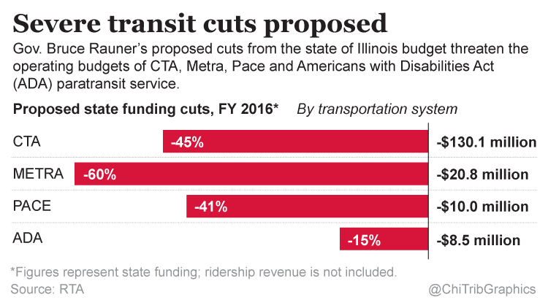

Citizens Taking Action

*for transit dependent riders*

March 19, 2015

For Information:

Charles Paidock, Secretary (312) 842-5036 [cpaidock@hotmail.com](mailto:cpaidock@hotmail.com)

Kevin Peterson (773) 896-8126 [transitcatt@hotmail.com](mailto:transitcatt@hotmail.com)

Citizens Taking Action is launching a vigorous lobbying campaign with Illinois state legislators to counter the Governor’s proposed cuts in funding for the three (3) public transit services in the Chicago metropolitan area. A study by the organization revealed a pattern of ongoing service cuts in CTA bus routes over the past 5 years, and fears that additional cuts in service will take place if state support is decreased.

Charles Paidock, Secretary, stated that: “It looks like all that we are going to have left soon is a skeleton of transit service for the rush hour only, on less frequent and overcrowded vehicles. Trying to get around at any other time may be a challenge. People are not going to choose public transit as their mode of travel if it simply does not go where you have to, or at a time when you want to go. Also, instead of taxes, passengers are going to have to pay by putting more money into the fare box, and the Governor will then claim that he reduced spending.”

Kevin Peterson, Co-Director, said: “Lower income people who are working poorer paying jobs are going to be hit the hardest. These comprise a large segment of the transit community, the transit dependent riders.”